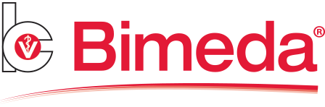
1st August 2017

Bimeda Autumn Promotion
– United Farmers

Bimeda is offering United Farmer members the opportunity to take advantage of some additional rebate on the Bimectin Plus Promo pack and the Endofluke Value Pack.
Offers run until the end of September 2017 and orders can be placed direct using the following email address: uksales@bimeda.com.

- Bimectin Plus Injection Promo Pack – 1.25L + Injector
Ivermectin 10mg/mL and Clorsulon 100mg/mL

- Endofluke Value Pack – 3 x 5L
Triclabendazole 100mg per mL

Product | List Price | Net Price | Net Price after 5% rebate |  | Offer | Offer rebate | Net Price | Net Price after offer rebate and standard 5% rebate
Bimectin Plus Promo Pack | £216.30 | £114.91 | £104.09 |  | Additional 5% | £10.82 | £104.09 | £93.27
Endofluke Value Pack | £405.00 | £229.50 | £209.25 |  | Additional 5% | £20.25 | £209.25 | £189.00
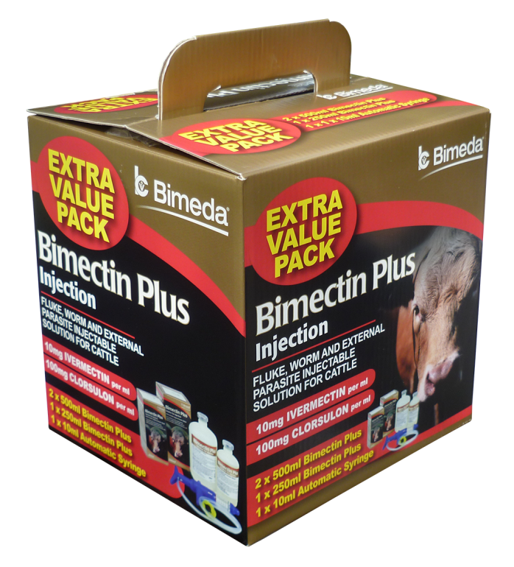
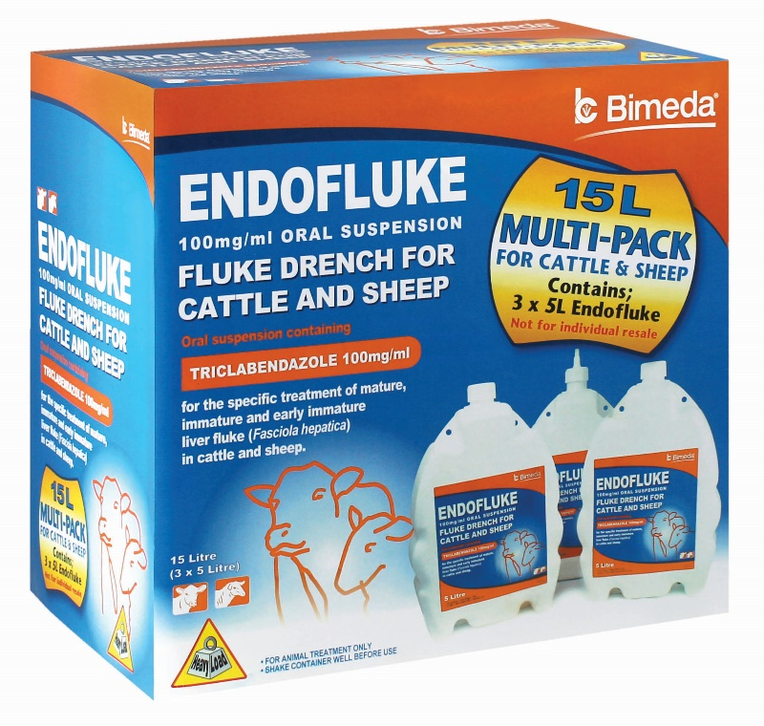

Support literature and CPD training available

Bimeda can also offer support literature for SQPs and Farmers along with interactive CPD training on Liver Fluke.
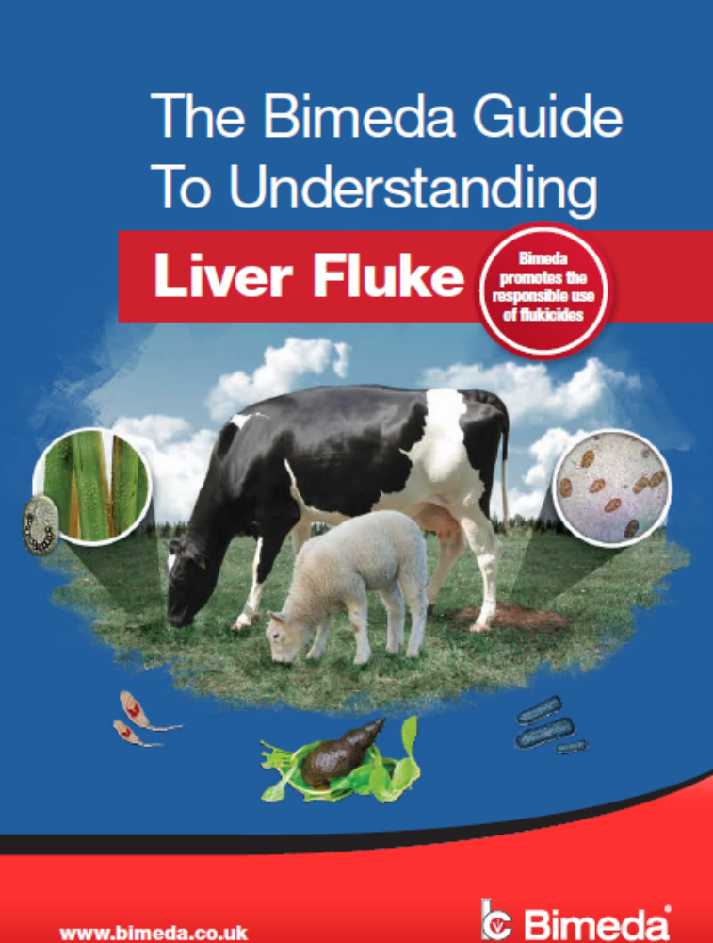

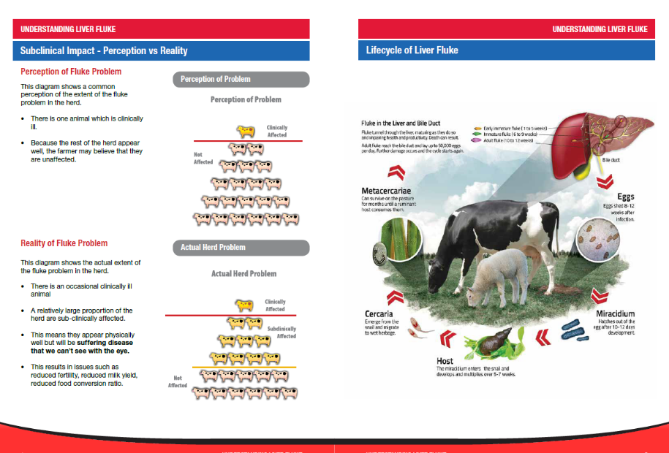

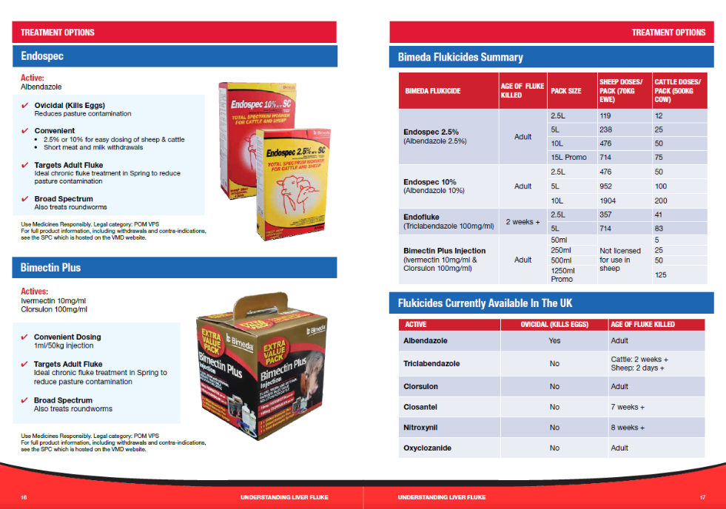

These are available to all UF members – to order some of the materials or to book some CPD training please contact your Territory Manager or Key Account Manager Emma Wormington.

Emma Wormington | Territory Manager (South East) and Key Account Manager

M+44 7889 809267 | T +44 1248 725400 | F +44 1248 725416
ewormington@bimeda.com | www.bimeda.co.uk

